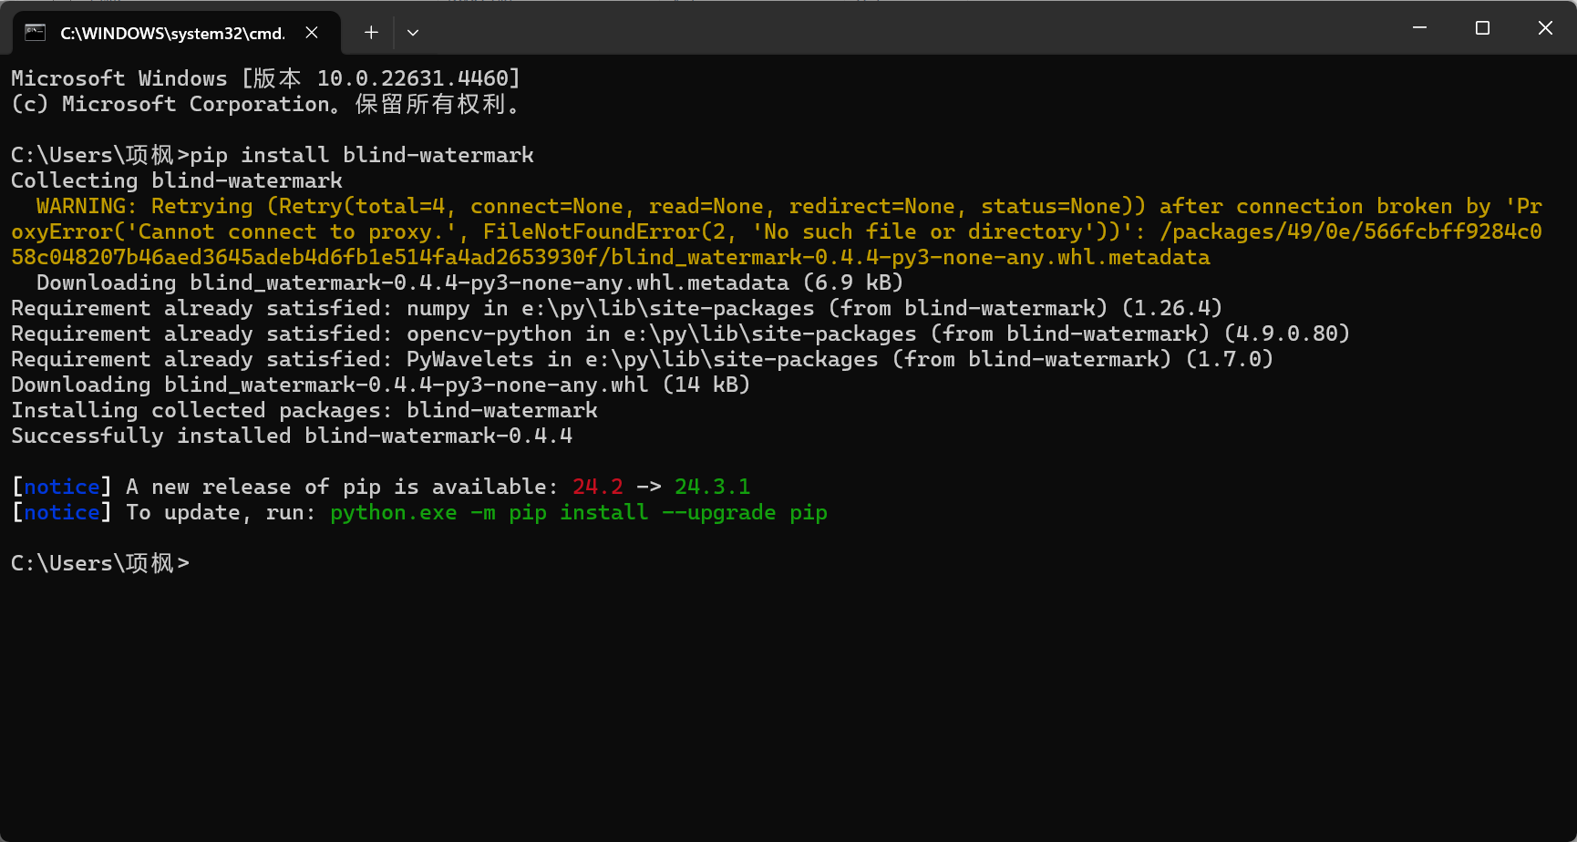
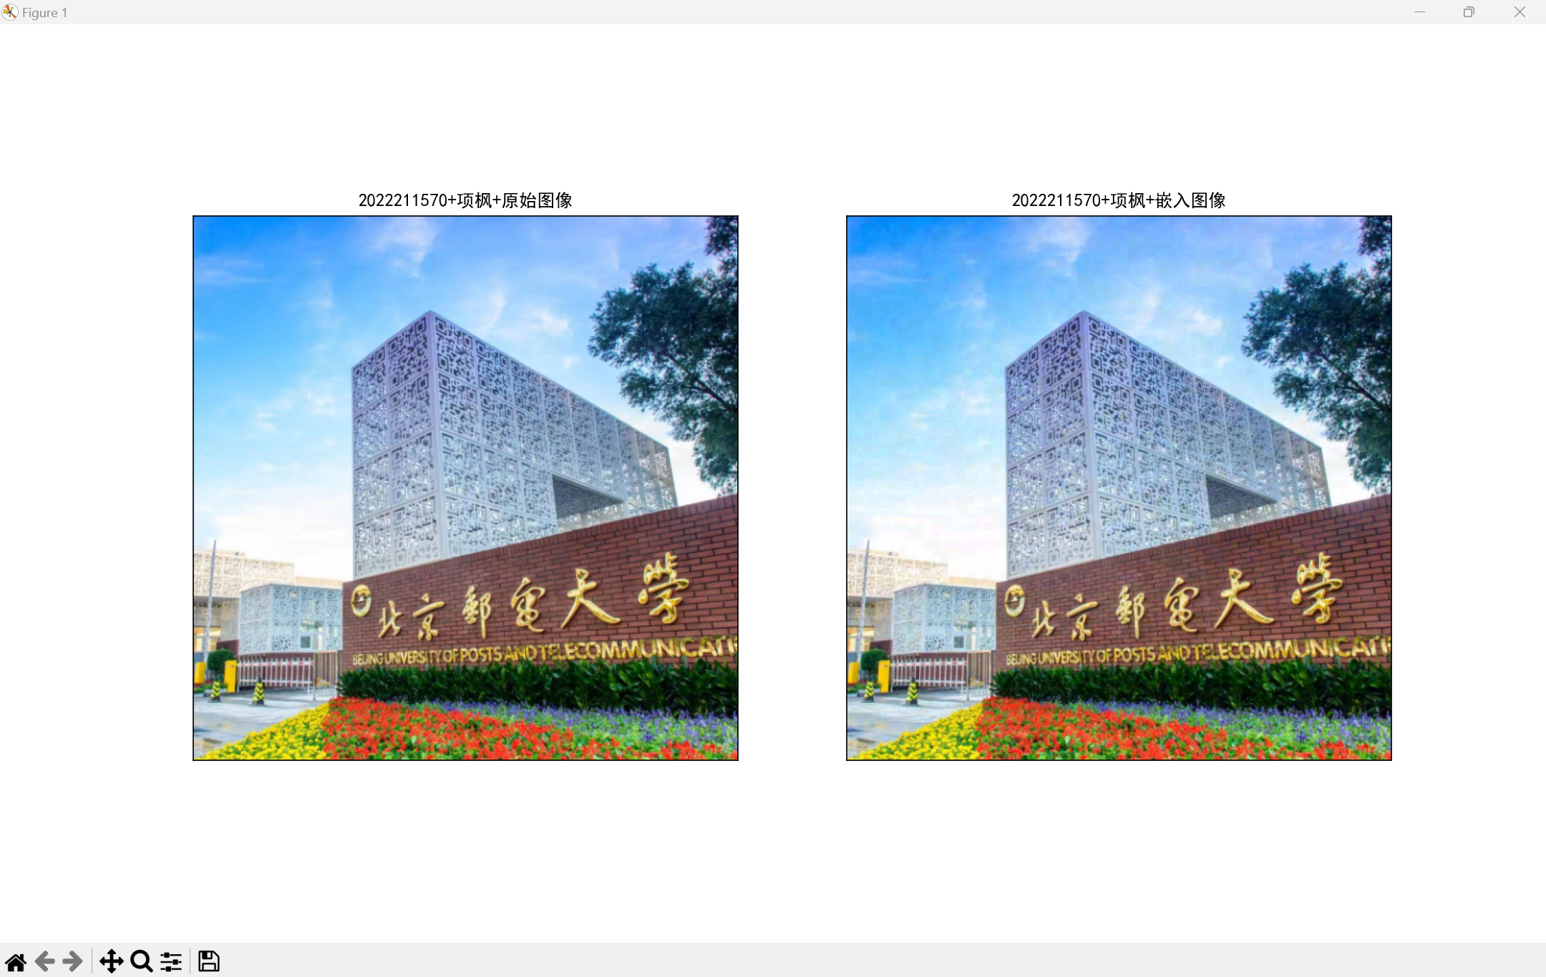
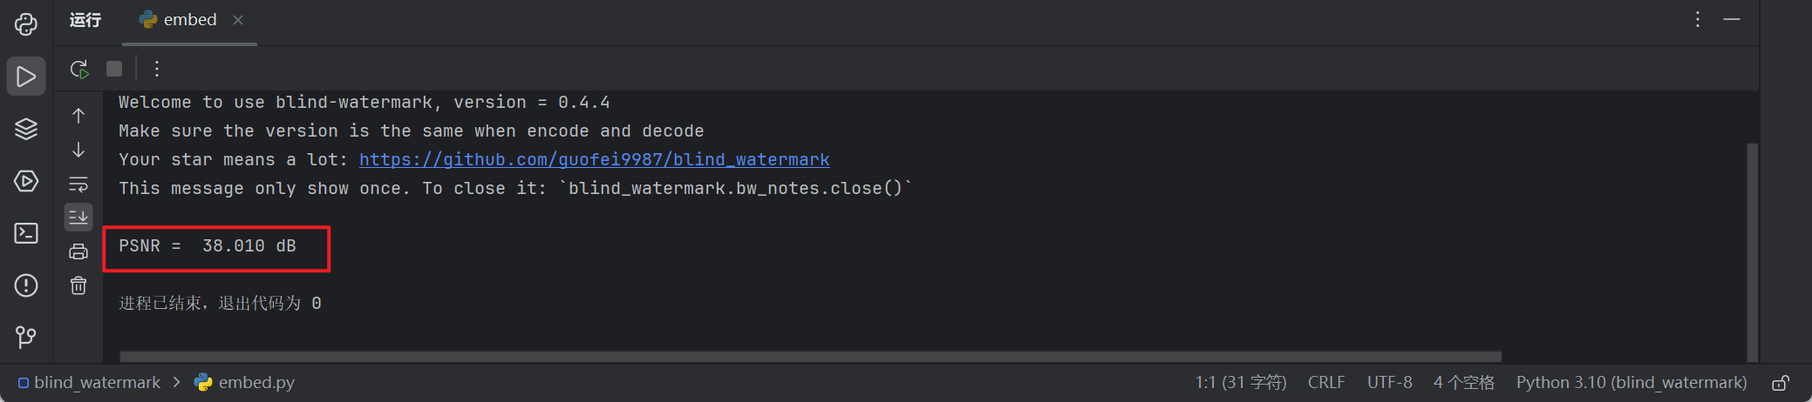
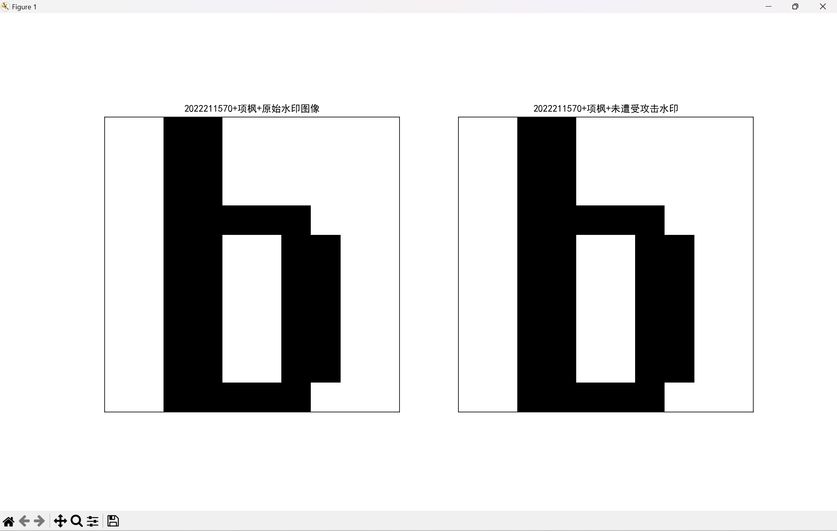
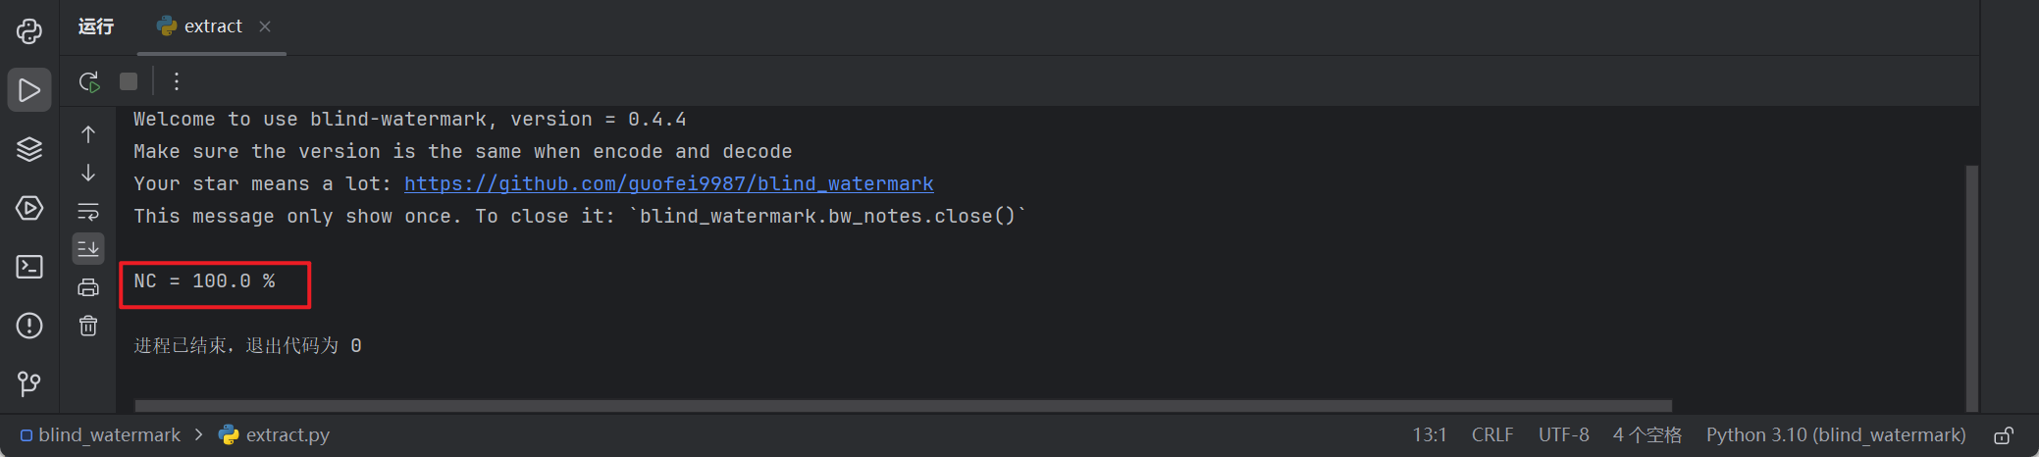

[1] 郭飞. blind_watermark[EB/OL].（2023-06-23）[2023-11-23]. https://github.com/guofei9987/blind_watermark.

